**Weekly report**

*Work on TFRecords and CASIA dataset*

Seemed to get TFRecords to work in a network but the accuracy was jumping all over the place as below.

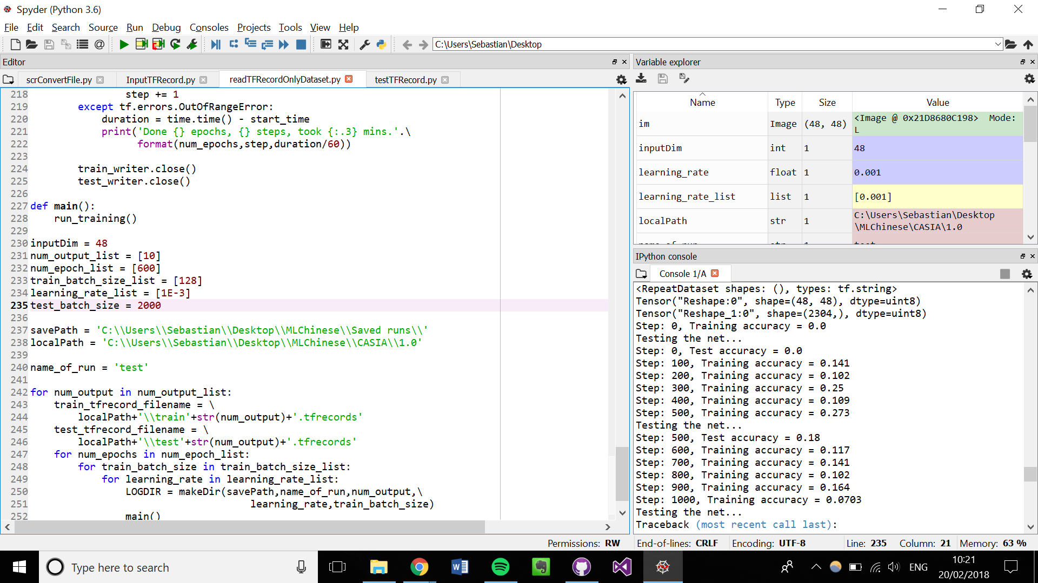

Figure : Training and testing accuracy jumping around all over the place

It turned out that there were no labels for the data. This was quickly fixed.

In the meantime, we figured out how to augment our images with rotation, translation, changing the brightness, and scaling. Scaling didn’t work well so we didn’t implement it.

Right now this data augmentation is applied to the whole dataset, once, so it’s not that useful. Ideally we want to augment the data each epoch.



Figure 2: Example of rotated image (over-rotated to show the rotation)



Figure : Example of adjusted brightness image



Figure : Example of image translation (over-translated to show effect)



Figure : Scaling doesn't seem to work because the lines on the characters are so thin that the image is too grainy

*Using the text in the CASIA database*

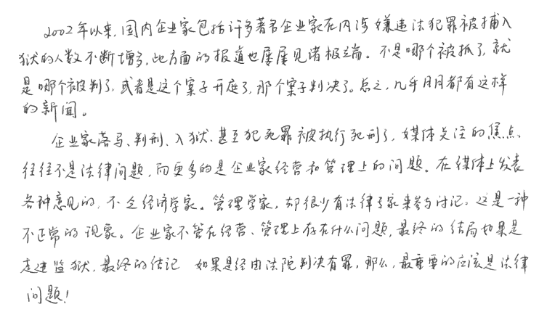

Figure 6: Sample of text from the CASIA database

We realised that if we want to work on calligraphy, we may want to build a neural network that can segment text into characters, or just read text as it is.

To test how good it was, we used Tesseract on the a sample text file from the CASIA database as above. Tesseract identified ~5 characters correctly, although it did seem to do well at segmenting the characters.

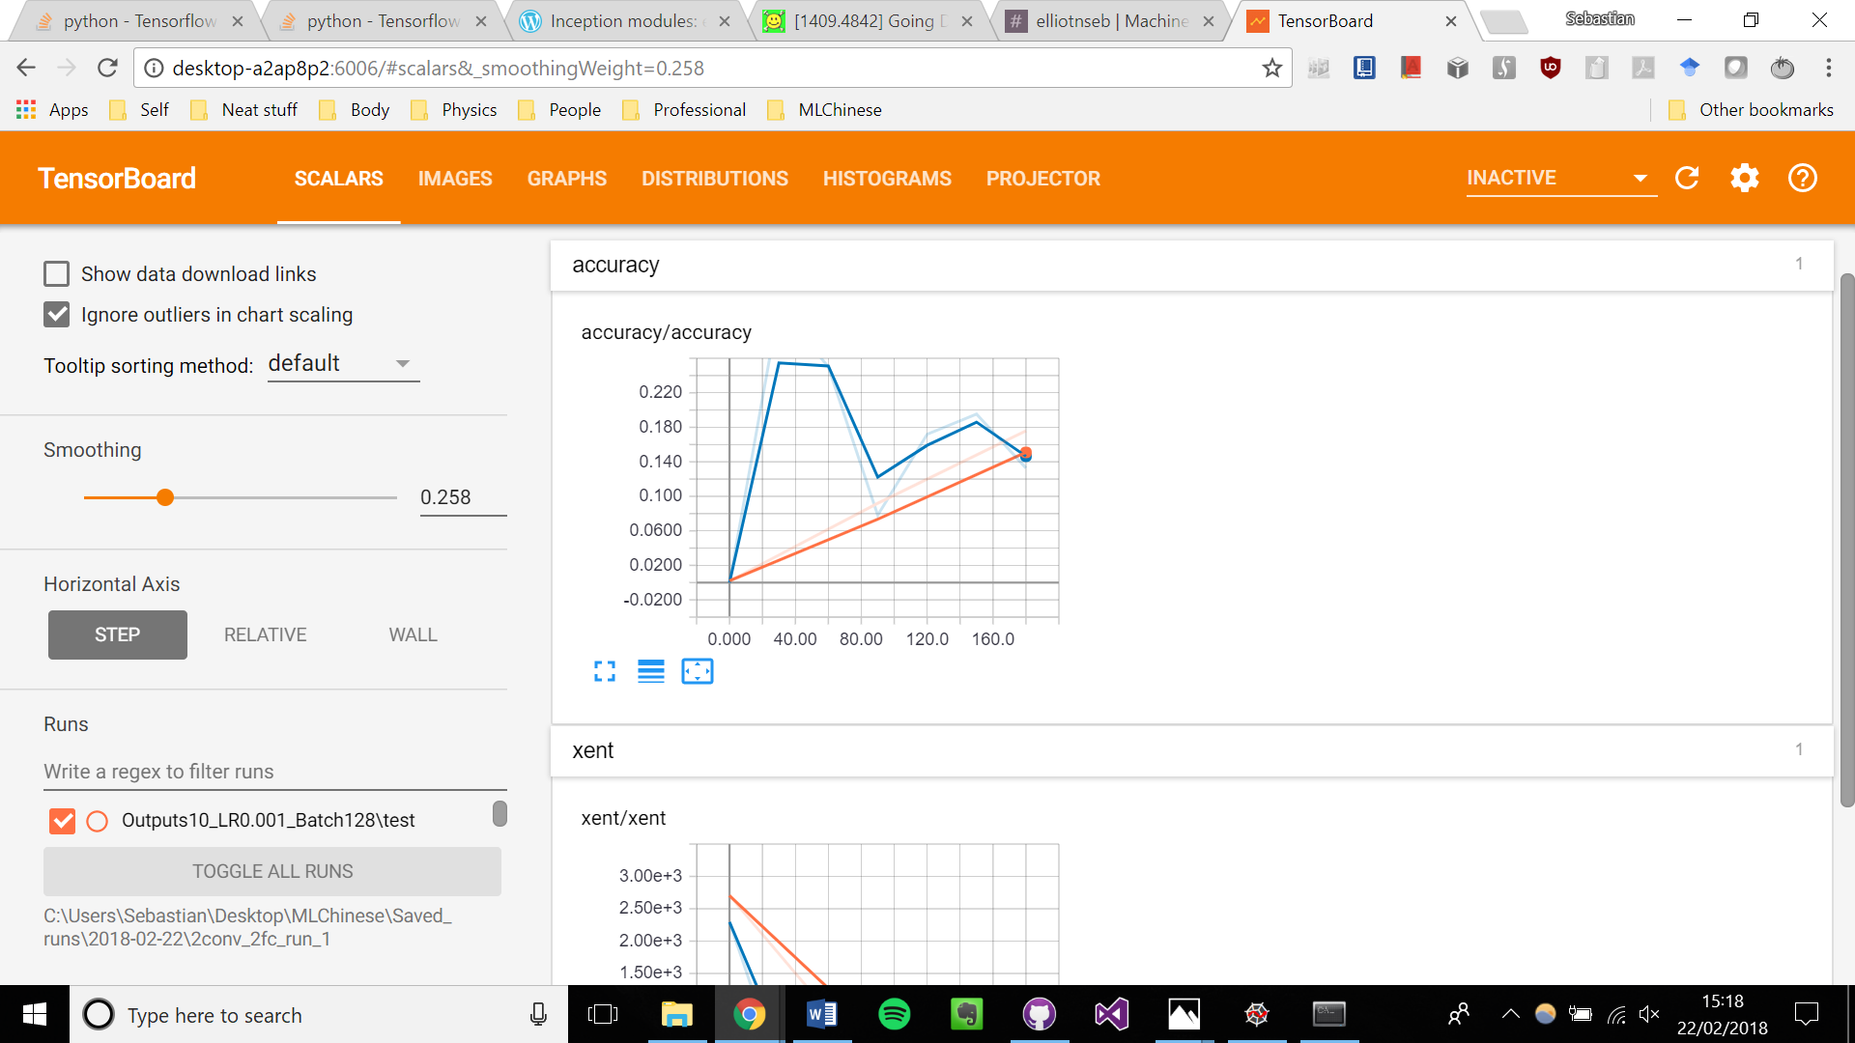

Figure 7: The beginning of training a 2-convolutional neural network with TFRecords files

We finally got TFRecords to work, successfully built a simple network with it, and also built a convolutional network which we ran as above for a brief while.

A big plus is that shuffling the data gives a huge(!) change in the accuracy training time. It seems to be very effective. Now we can also read in all the .gnt files we want, rather than limiting ourselves with samples of .gnt files.

*Crossroads in our research*

We are at a significant crossroads in our research.

We have emailed the Professors that organise the CASIA database and they have told us that there is no large database of labelled Chinese characters.

There are several options to proceed. The simplest and the one to start with is just to train our network to a reasonable accuracy on isolated handwritten Chinese characters, and then manually split up a piece of calligraphy into isolated characters, feed it into our network, and see how it does.

*Work on transfer learning*

I have successfully read in and saved the bottlenecks for a CNN although as we were on our laptops the CNN was not well trained. There are just a few bugs to iron out with regards to training the final layer with the bottlenecks.

Work on Neural network class

Because the transfer learning work required the TFrecords stuff to be up and running, we worked on making it much simpler to create a neural network.

We went about making a class that had member functions to add a particular layer. The function would calculate the necessary sizes other than the specified number of outputs and would add the necessary variables and functions to the TensorFlow computational graph. This is not yet complete and is a lower priority task.

**Action points for the next week**

1. Train a CNN using TFrecords and perform transfer learning from 10 to 30 outputs.

2. Look at training more complex CNNs to up the accuracy of our model to the required standard.

3. Continue to consider the future of our project beyond isolated character recognition.